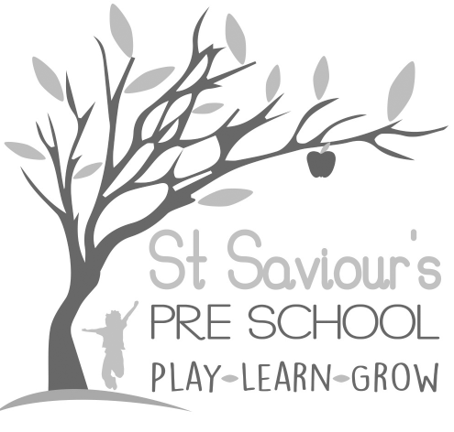

1.1 CHILD PROTECTION

Written by: Claire Toms and Tina Alder Date: 1.09.22. – reviewed 27.08.25.

Policy Statement
St Saviour’s Preschool aims to provide a safe, caring environment, which encourages each child to be independent and confident. We aim to protect children from maltreatment, to prevent impairment of health or development, and to ensure they are provided with safe and effective care.
We actively promote respect of their own and others’ home languages, ethnicity, beliefs, and individuality. We will challenge any behaviour (staff, children or parents) that is not in line with the fundamental British values of democracy, rule of law, individual liberty, mutual respect and tolerance for those with different faiths and beliefs (see Prevent Policy). Staff will actively promote British values and will have regard to Government requirements to promote children’s welfare and prevent radicalisation and extremism.
We promote the children’s right to be strong, resilient, and listened to, by encouraging children to develop a strong sense of autonomy and independence, and by enabling them to build the self-confidence and vocabulary required, to resist inappropriate approaches. This is supported by our Key-person strategy, which ensures that staff members are trained to listen to children and can recognise changes in their behaviour or demeanour and are trained to respond appropriately.
We help children to establish and sustain satisfying relationships within their families, with peers, and other adults.
We work with parents/carers to build their understanding of, and commitment to the principles of safeguarding all our children.
We have clear safeguarding procedures in place to ensure compliance with the EYFS 2025 statutory requirements, including:
- Whistleblowing procedures, enabling staff, volunteers and students to safely raise concerns internally or externally (e.g. NSPCC, Ofsted).
- Absence monitoring procedures, ensuring we contact parents and emergency contacts promptly if a child is not brought in, track patterns of attendance, and act on any prolonged or unexplained absences.
- Safer recruitment practices, including obtaining verified references directly from senior figures (not family members), cross-checked with application information.
- Enhanced Designated Safeguarding Lead (DSL) training refreshed at least every two years.
- Paediatric First Aid (PFA): at least one staff member with current PFA is present at all times, including during snacks and mealtimes. Trainees are only included in ratios if PFA-qualified and assessed as competent.
- Implementation of the new DfE nutrition guidance: dietary and allergy information is gathered prior to admission, safe eating is closely supervised, and any choking or eating incidents are recorded and reviewed.
- Respectful and private toileting and personal care routines, carried out one-to-one, balancing dignity and safeguarding oversight.

What it means to promote children’s rights and entitlements to be ‘strong, resilient and listened to’:
To be strong means to be:
• secure in their foremost attachment relationships, where they are loved and cared for by at least one person who can offer consistent, positive, and unconditional regard and who can be relied on.
• safe and valued as individuals in their families and in relationships beyond the family, such as nursery or school.
• self-assured and form a positive sense of themselves – including all aspects of their identity and heritage.
• included equally and belong in our setting and in community life.
• confident in their own abilities and proud of their achievements.
• progressing optimally in all aspects of their development and learning.
• supported by a safe and healthy environment, with staff who follow updated EYFS 2025 safeguarding, absence, recruitment, and health requirements.
To be resilient means to:
• be sure of their self-worth and dignity.
• be able to be assertive and state their needs effectively.
• be able to overcome difficulties and problems.
• be positive in their outlook on life.
• be able to cope with challenge and change.
• have a sense of justice towards themselves and others.
• develop a sense of responsibility towards themselves and others.
• know that the adults who care for them are well-trained, vigilant, and supported by strong safeguarding policies that keep them safe.
To be listened to means:
• adults who are close to children recognise their need and right to express and communicate their thoughts, feelings and ideas.
• adults who are close to children are able to tune in to their verbal, sign and body language in order to understand and interpret what is being expressed and communicated.
• adults who are close to children are able to respond appropriately and, when required, act upon their understanding of what children express and communicate.
• adults respect children’s rights and facilitate children’s participation and representation in imaginative and child-centred ways in all aspects of core services.
• staff take account of safeguarding guidance, attendance information, and health records to ensure every child’s voice and welfare needs are heard, recorded, and acted upon in line with statutory requirements.

